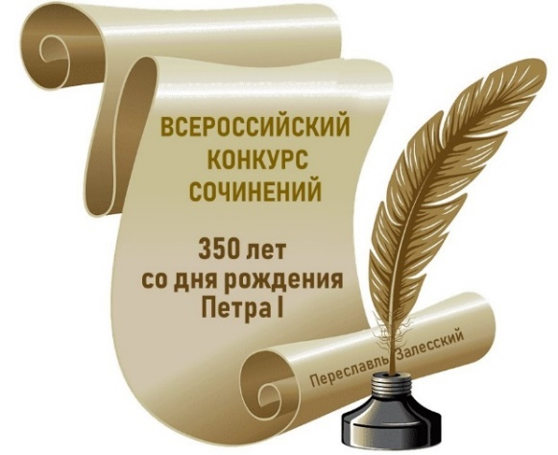
Участник Конкурса:
_________________________________________
Фамилия
_________________________________________
Имя
_________________________________________
Отчество

Субъект Российской Федерации:
______________________________________________________________________
Наименование муниципального образования (населённого пункта):
______________________________________________________________________
Образовательная организация (полное название в соответствии с Уставом):
______________________________________________________________________
______________________________________________________________________
Класс (курс), в (на) котором обучается участник Конкурса:
______________________________________________________________________
Тематическое направление:
______________________________________________________________________
______________________________________________________________________
Жанр:
______________________________________________________________________
Тема:
______________________________________________________________________
______________________________________________________________________
______________________________________________________________________

Сочинение:
________________________________________________________________________
________________________________________________________________________
________________________________________________________________________
________________________________________________________________________
________________________________________________________________________
________________________________________________________________________
________________________________________________________________________
________________________________________________________________________
________________________________________________________________________
________________________________________________________________________
________________________________________________________________________
________________________________________________________________________
________________________________________________________________________
________________________________________________________________________
________________________________________________________________________
________________________________________________________________________
________________________________________________________________________
________________________________________________________________________
________________________________________________________________________
________________________________________________________________________
________________________________________________________________________
________________________________________________________________________
________________________________________________________________________
________________________________________________________________________
________________________________________________________________________
________________________________________________________________________
________________________________________________________________________
________________________________________________________________________
________________________________________________________________________
________________________________________________________________________
________________________________________________________________________
________________________________________________________________________
________________________________________________________________________
________________________________________________________________________
________________________________________________________________________
________________________________________________________________________
________________________________________________________________________
________________________________________________________________________
________________________________________________________________________
________________________________________________________________________
________________________________________________________________________
________________________________________________________________________
________________________________________________________________________
________________________________________________________________________
________________________________________________________________________
________________________________________________________________________
________________________________________________________________________
________________________________________________________________________
________________________________________________________________________
________________________________________________________________________
________________________________________________________________________
________________________________________________________________________
________________________________________________________________________
________________________________________________________________________
________________________________________________________________________
________________________________________________________________________
________________________________________________________________________
________________________________________________________________________
________________________________________________________________________
________________________________________________________________________
________________________________________________________________________
________________________________________________________________________
________________________________________________________________________
________________________________________________________________________
________________________________________________________________________
________________________________________________________________________
________________________________________________________________________
________________________________________________________________________
________________________________________________________________________
________________________________________________________________________
________________________________________________________________________
________________________________________________________________________
________________________________________________________________________
________________________________________________________________________
________________________________________________________________________
________________________________________________________________________
________________________________________________________________________
________________________________________________________________________
________________________________________________________________________
________________________________________________________________________
________________________________________________________________________
________________________________________________________________________
________________________________________________________________________
________________________________________________________________________
________________________________________________________________________
________________________________________________________________________
________________________________________________________________________
________________________________________________________________________
________________________________________________________________________
________________________________________________________________________
________________________________________________________________________
________________________________________________________________________
________________________________________________________________________
________________________________________________________________________
________________________________________________________________________
________________________________________________________________________
________________________________________________________________________
________________________________________________________________________
________________________________________________________________________
________________________________________________________________________
________________________________________________________________________
________________________________________________________________________
________________________________________________________________________
________________________________________________________________________
________________________________________________________________________
________________________________________________________________________
________________________________________________________________________
________________________________________________________________________
________________________________________________________________________
________________________________________________________________________
________________________________________________________________________
________________________________________________________________________
________________________________________________________________________
________________________________________________________________________
________________________________________________________________________
________________________________________________________________________
________________________________________________________________________
________________________________________________________________________
________________________________________________________________________
________________________________________________________________________
________________________________________________________________________
________________________________________________________________________
________________________________________________________________________
________________________________________________________________________
________________________________________________________________________
________________________________________________________________________
________________________________________________________________________
________________________________________________________________________
________________________________________________________________________
________________________________________________________________________
________________________________________________________________________
________________________________________________________________________
________________________________________________________________________
________________________________________________________________________
________________________________________________________________________
________________________________________________________________________
________________________________________________________________________
________________________________________________________________________
________________________________________________________________________
________________________________________________________________________
________________________________________________________________________
________________________________________________________________________
________________________________________________________________________
________________________________________________________________________
________________________________________________________________________
________________________________________________________________________
________________________________________________________________________
________________________________________________________________________
________________________________________________________________________
________________________________________________________________________
________________________________________________________________________
________________________________________________________________________
________________________________________________________________________
________________________________________________________________________
________________________________________________________________________
________________________________________________________________________
________________________________________________________________________
________________________________________________________________________
________________________________________________________________________
________________________________________________________________________

